H.T No
Regulations:
A18

Sreenidhi Institute of Science and Technology
(An Autonomous Institution)
Code No: 7K404 Date: 13-July-2021 (AN)

B.Tech II-Year II- Semester Pending External Examination, July - 2021 (Supplementary)
MECHANICS OF MATERIALS (CIVIL)

Time: 3 Hours Max.Marks:70

Note: a) No additional answer sheets will be provided.
b) All sub-parts of a question must be answered at one place only, otherwise it will not be valued.
c) Missing data can be assumed suitably.

ANSWER ANY 5 OUT OF 8 QUESTIONS. EACH QUESTION CARRIES 14 MARKS.

Bloom's Cognitive Levels of Learning (BCLL)

Remember | L1 | Apply | L3 | Evaluate | L5
Understand | L2 | Analyze | L4 | Create | L6

 |  |  | BCLL | CO(s) | Marks
1. |  | A straight bar 60cm long consists of three portions the first 18 cm length is of 30mm diameter, the middle 26 cm length is of 20mm dia. and the remaining 16 cm length is of 25 cm dia. If it is subjected to an axial pull of 100kN find the total extension of the bar. Find also the stresses, strains and changes in length of different portions. Take E = 200 GPa. | L3 | CO1 | [14M]
2. |  | A shaft is loaded by a torque of 5 KN-m. The material has a yield point of 350 MPa. Find the required diameter using (a) Maximum shear stress theory (b) Maximum distortion energy theory Take a factor of safety of 2.5. | L3 | CO2 | [14M]
3. |  | A beam 8.5m long rests on supports 5m apart. The right hand end overhang is 2m and left end overhang is 1.5m.it carries a uniformly distributed load of 50kN/m run between the supports. A point load of 60kN acts at the extreme right end and another point load 40kN acts at the left hand end. Construct the SFD and BMD and state the position of the points of inflexion. | L4 | CO3 | [14M]
4. |  | Analyze the trusss 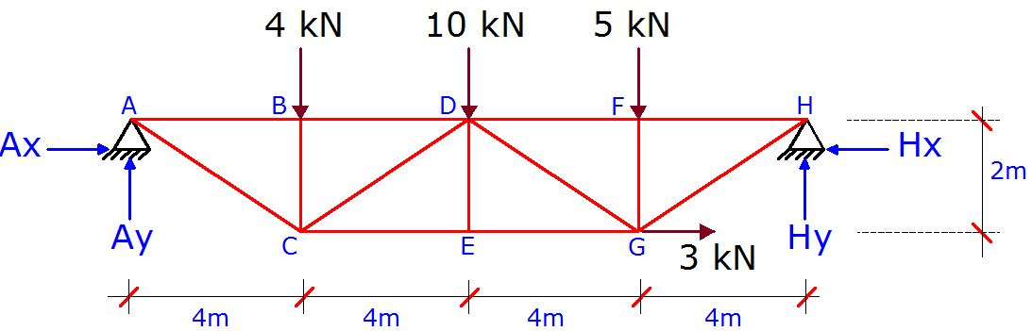 | L4 | CO4 | [14M]
5. |  | Find the deflection at the free end of the beam as shown in fig. Using any energy method.  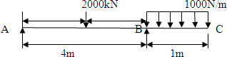 | L4 | CO5 | [14M]
6. |  | A column having a T section with a flange 120 mm x 16 mm and web 150 mm x 16 mm is 3m long. Assuming the column to be hinged at both ends, find the crippling load by Euler’s Formula .Assume E=210MPa | L4 | CO6 | [14M]
7. | a) | Explain the stress strain curve for a mild steel specimen | L2 | CO1 | [5M]
 | b) | Explain in brief about strain tensor | L2 | CO2 | [5M]
 | c) | Explain in brief about the failure criteria in frames | L3 | CO3 | [4M]
8. | a) | Explain in detail about force deformation relationships of deformable bodies | L3 | CO4 | [5M]
 | b) | What is the ratio of torsional moments of resistance of a solid circular shaft of diameter D to that of a hallow shaft with external diameter D and internal diameter‘d’? | L4 | CO5 | [5M]
 | c) | Explain in brief about Rankine’s theory | L3 | CO6 | [4M]

-- 00 -- 00 –

